**IFT 266 Introduction to Network Information Communication Technology   
  
Lab 18**

**The Hidden Network**Co-authored by Ricardo Garcia

**Note: This is a challenging lab. Ask other students for help if you need it.   
  
After you complete each step, put an ‘x’ in the completed box or answer the open question or attach a screenshot as indicated**

**Objective:** Demonstrate an understanding of using telnet and using a variety of show commands to reconstruct the network using the provided devices

All VTY passwords are set to cisco

Enable passwords are not available

In the cluster that the computer Alice X can see, there is already a network configured and working, use the devices on the left with cabling included to connect the physical topology of the already configured network within packet tracer using commands

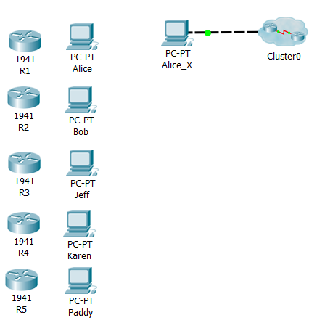 **Helpful show commands**

* show ip interface brief
* show ip route
* show ip protocol
* show ip arp
* show controllers serial x/x/x
* show cdp neighbor
* show cdp neighbor detail
* show interface serial x/x/x

**Couple of helpful hints!**

* Once you have looked at the configuration of the router by using the corresponding commands, use this data to build the physical network topology within packet tracer, starting with finding out what Alice connects to.
* If you get stuck, try looking at the PC IP configuration i.e. checking the gateway of the PC's and then finding the corresponding router with that gateway, but then using CDP neighbors command to see what was connected via Serial router to router

1. Go into the Command Prompt for Alice_X and run ipconfig command.
2. What address can you use from Alice_X to telnet into another device?  
     
    ______________________________________________________
3. Using the Address from above in Command Prompt run the telnet command

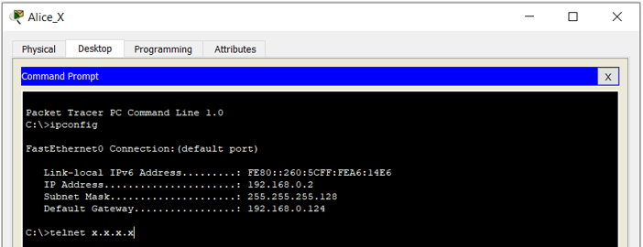

1. If you used the correct address, then it should prompt as follows. The password for this is **cisco** as well as for all other routers when establishing a telnet connection.



1. Once the connection is established use the helpful commands listed above to go through the devices configuration as needed to figure out what devices are connected to R3. You will need to run these commands from user mode and will not the password to enter enable mode.

show ip interface brief

show ip route

show ip protocol

show ip arp

show controllers serial x/x/x

show cdp neighbor

show cdp neighbor detail

show interface serial x/x/x



1. What device is shown if you run **show cdp neighbors**? ______________
2. What command can you use to find the Default Gateway for that Device? And what is the address for the Default Gateway?

______________________________________________________

1. From this point you should have three devices connected.   
     
   Attach a screenshot of your three devices below.

1. Moving forward repeat these steps and use the helpful commands as needed to reconnect the rest of the network.
2. Attach a screenshot of the fully reconnected network below.

1. Attach a screenshot of a successful ping from Alice to Paddy below.